

PROJECT REPORT

**COURSE: COMPUTER PROGRAMMING**

**GROUP MEMBERS:**

**RIMSHA JAVED (SP19-BSCS-0028)**

**ALI TAIMOOR KHAN (SP19-BSSE-0067)**

**HUMAYUN KHAN JALBANI (SP19-BSSE-0060)**

**OSAMA BIN SAJID (SP19-BSSE-0033)**

**Date : 23-MAY,2019**

**Project Title:** Mp3 Player using Pygame

**Introduction :**

* This is a GUI based mp3 audio player
* This player will play mp3 files, the buttons which are used play,stop,pause,mute, rewind, voume up and down.

**Libraries :**

The libraries which are used in this project are following:

* Tkinter
* Mutagen
* Ttkthemes
* Pygame

**Tkinter**

Tkinter is the standard GUI library for Python. Python when combined with Tkinter provides a fast and easy way to create GUI applications. Tkinter provides a powerful object-oriented interface to the Tk GUI toolkit.

**Mutagen**

Mutagen is a Python module to handle audio metadata. It supports ASF, FLAC, MP4, Monkey’s Audio, MP3, Musepack, Ogg Opus, Ogg FLAC, Ogg Speex, Ogg Theora, Ogg Vorbis, True Audio, WavPack, OptimFROG, and AIFF audio files. It can read Xing headers to accurately calculate the bitrate and length of MP3s.

**Ttkthemes**

It provides themes ,styles to the mp3 player .

**Pygame**

Pygame is a Python wrapper module for the SDL multimedia library. It contains python functions and classes that will allow you to use SDL’s support for playing cdroms, audio and video output, and keyboard, mouse and joystick input.

**Screenshot of the Project**

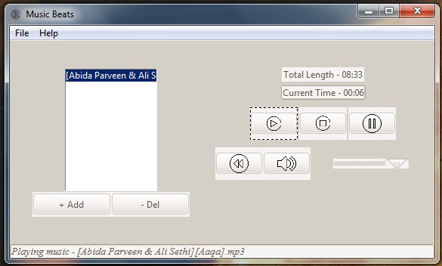

You can also add and delete the music , in this project we use play ,stop,paused, rewind volume functions.